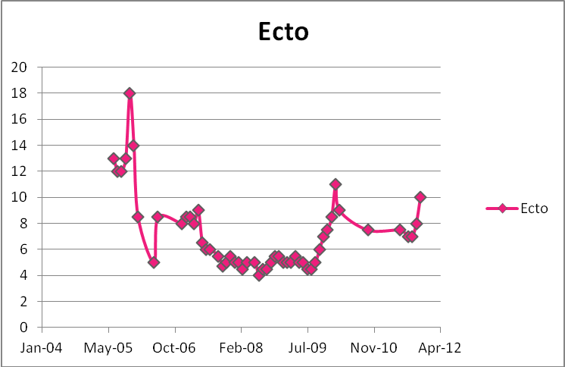
Date | Price(1000s)
Jul-05 | 13
Aug-05 | 12
Sep-05 | 12
Oct-05 | 13
Nov-05 | 18
Dec-05 | 14
Jan-06 | 8.5
May-06 | 5
Jun-06 | 8.5
Dec-06 | 8
Jan-07 | 8.5
Feb-07 | 8.5
Mar-07 | 8
Apr-07 | 9
May-07 | 6.5
Jun-07 | 6
Jul-07 | 6
Sep-07 | 5.5
Oct-07 | 4.7
Nov-07 | 5
Dec-07 | 5.5
Jan-08 | 5
Feb-08 | 5
Mar-08 | 4.5
Apr-08 | 5
Jun-08 | 5
Jul-08 | 4
Aug-08 | 4.5
Sep-08 | 4.5
Oct-08 | 5
Nov-08 | 5.5
Dec-08 | 5.5
Jan-09 | 5
Feb-09 | 5
Mar-09 | 5
Apr-09 | 5.5
May-09 | 5
Jun-09 | 5
Jul-09 | 4.5
Aug-09 | 4.5
Sep-09 | 5
Oct-09 | 6
Nov-09 | 7
Dec-09 | 7.5
Jan-10 | 8.5
Feb-10 | 11
Mar-10 | 9
Oct-10 | 7.5
Jun-11 | 7.5
Aug-11 | 7
Sep-11 | 7
Oct-11 | 8
Nov-11 | 10

